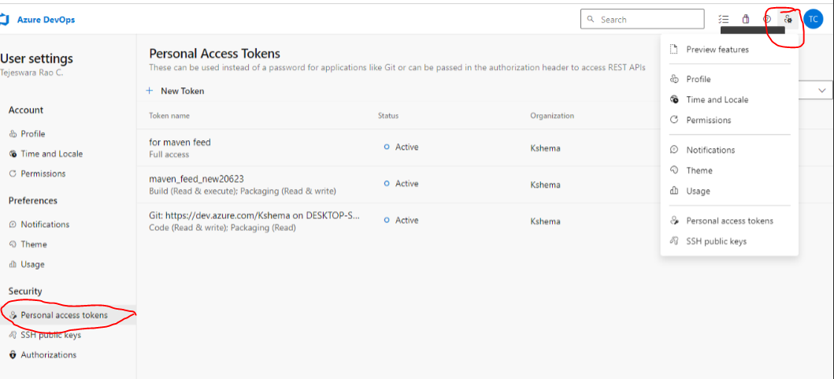

Above one is create a Personal access token:- go to profiles and drop down,

Fill the below details in personal Access token

Create a Service connection under iAgriOps :- go to project settings under service connection.

Fill the below details

Above image showing after maven connection Created.

Artifactor Creating:_

Go to artifacts—click on connect to feed-select maven—marked file insert in pom.xml (Developer will add this one)

Create a Artifact Feed Name:-

After fill the details click Connect feed.

Create a service connection

CI Code:__

trigger:

- main

pool:

  vmImage: ubuntu-20.04

stages:

  - stage: build

    jobs:

      - job:

        steps:

          - task: MavenAuthenticate@0

            inputs:

              artifactsFeeds: 'iAgriwar_Kshema'

              mavenServiceConnections: 'mavenfeedserviceconnection'

          - task: Maven@3

            inputs:

              mavenPomFile: 'pom.xml'

              goals: 'install'

              publishJUnitResults: true

              testResultsFiles: '**/surefire-reports/TEST-*.xml'

              javaHomeOption: 'JDKVersion'

              jdkVersionOption: '1.11'

              mavenVersionOption: 'Default'

              mavenOptions: '-Xmx3072m'

              mavenAuthenticateFeed: true

              effectivePomSkip: false

              sonarQubeRunAnalysis: false

          - task: CopyFiles@2

            displayName: 'Copy Files to: $(build.artifactstagingdirectory)'

            inputs:

              SourceFolder: '$(system.defaultworkingdirectory)'

              Contents: |

               **/target/*.war

              TargetFolder: '$(build.artifactstagingdirectory)'

          - task: PublishBuildArtifacts@1

            displayName: 'Publish Artifact: drop'

            inputs:

              PathtoPublish: '$(build.artifactstagingdirectory)'